Lab 10 – Create a physics-based game play to realize all basic Newtonian effects

[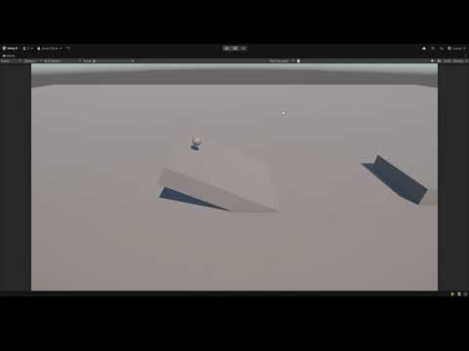](https://www.youtube.com/embed/DVc9woDMnBY?feature=oembed)

**1. Project Setup**

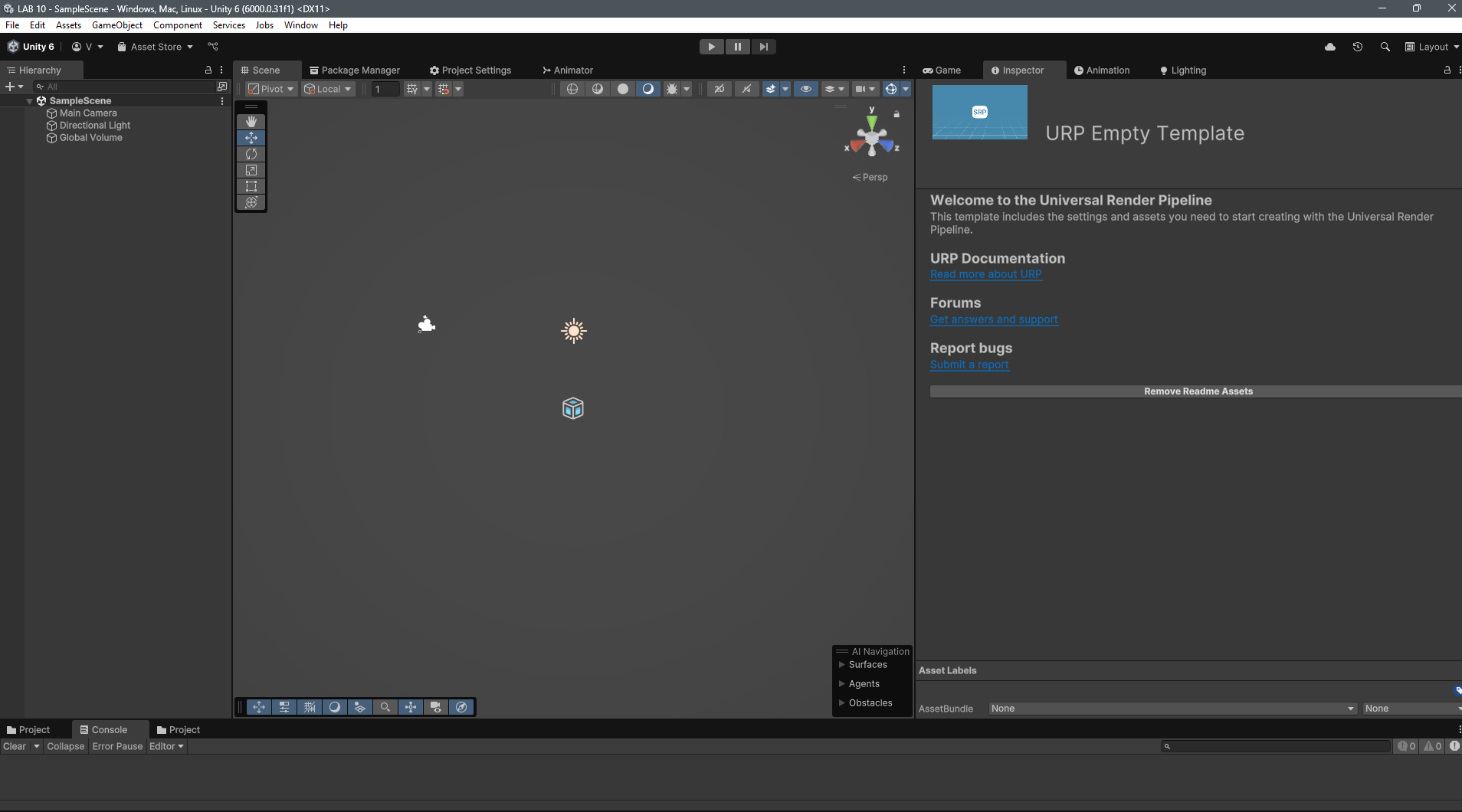

**2. Create the Ground/Platform**

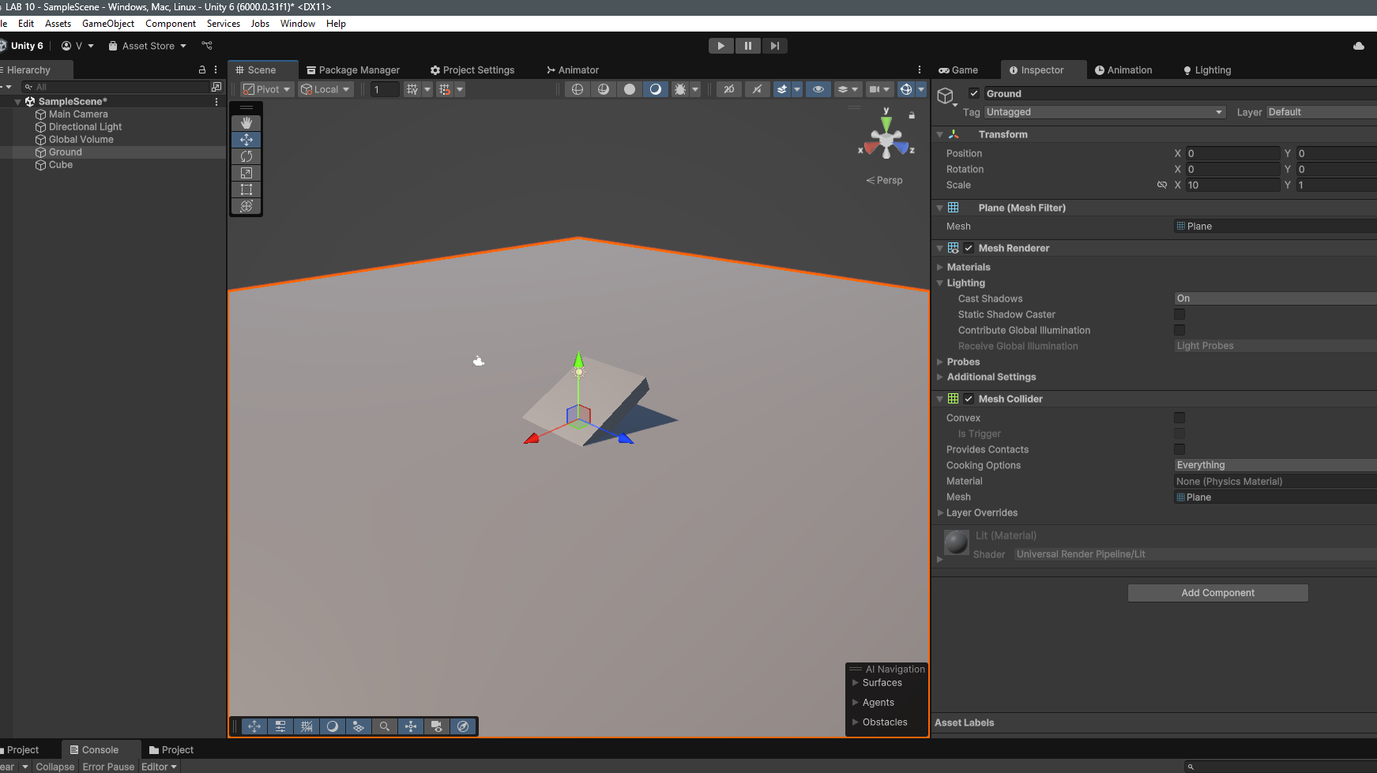

**3. Create the Ball**

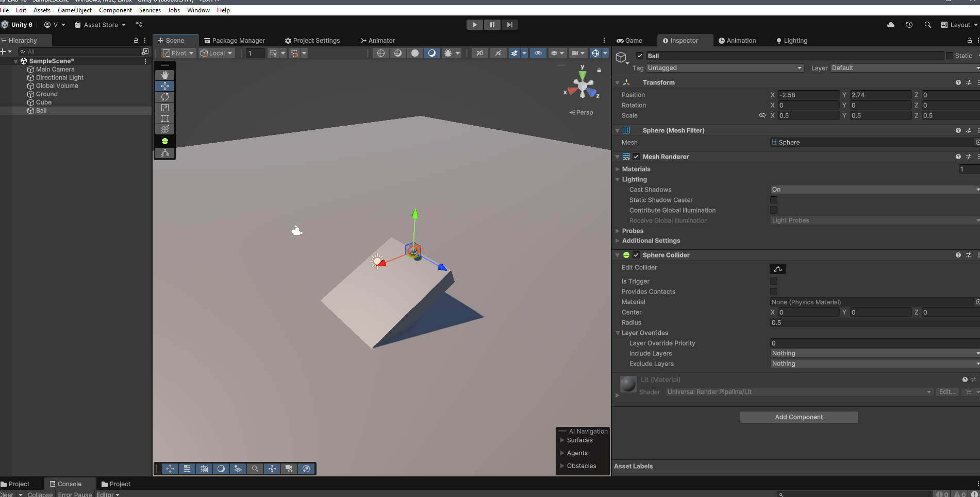

**4. Add Physics Components**

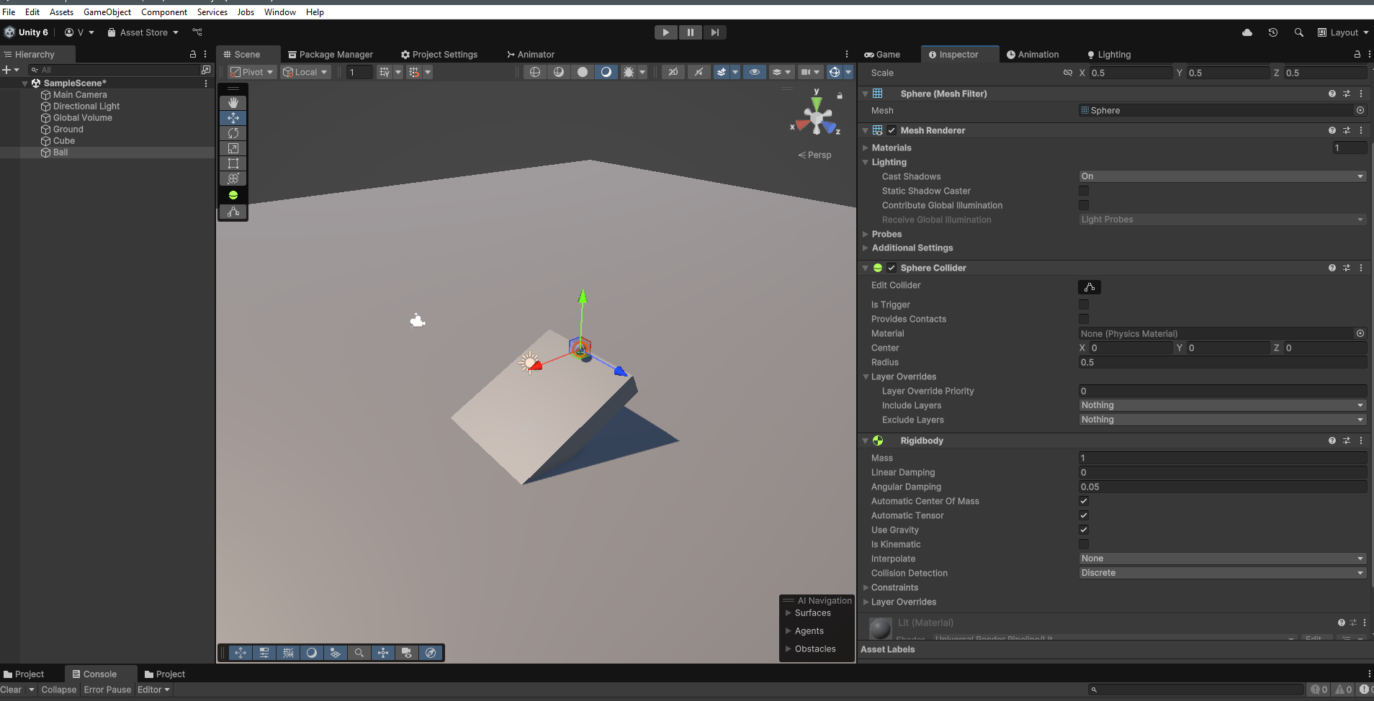

**5. Adjust Global Physics Settings**

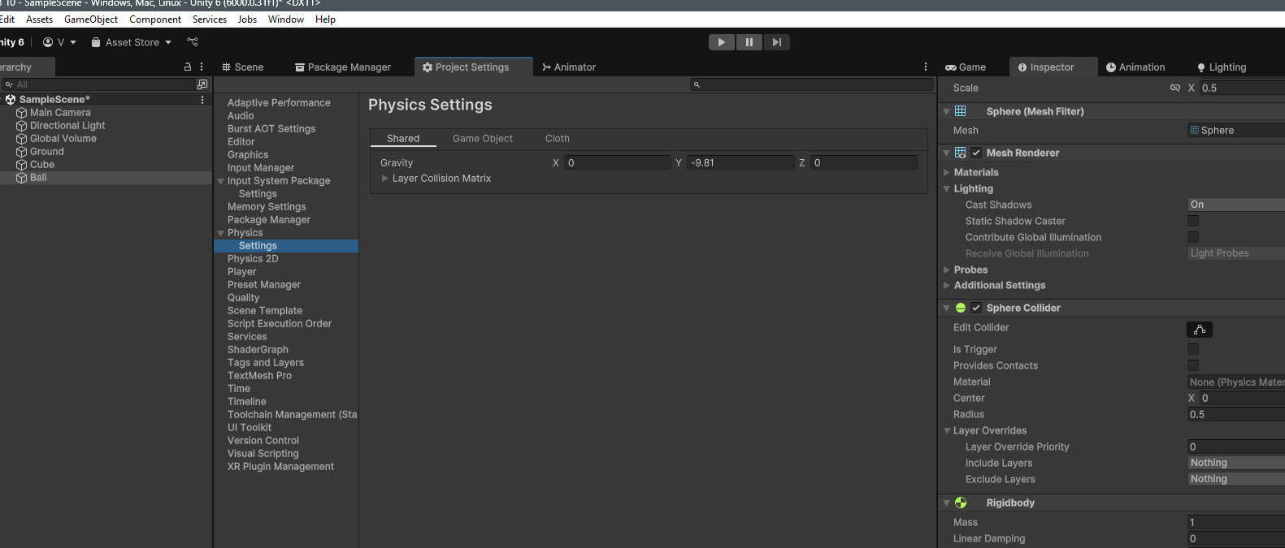

**6. Implement User Input**

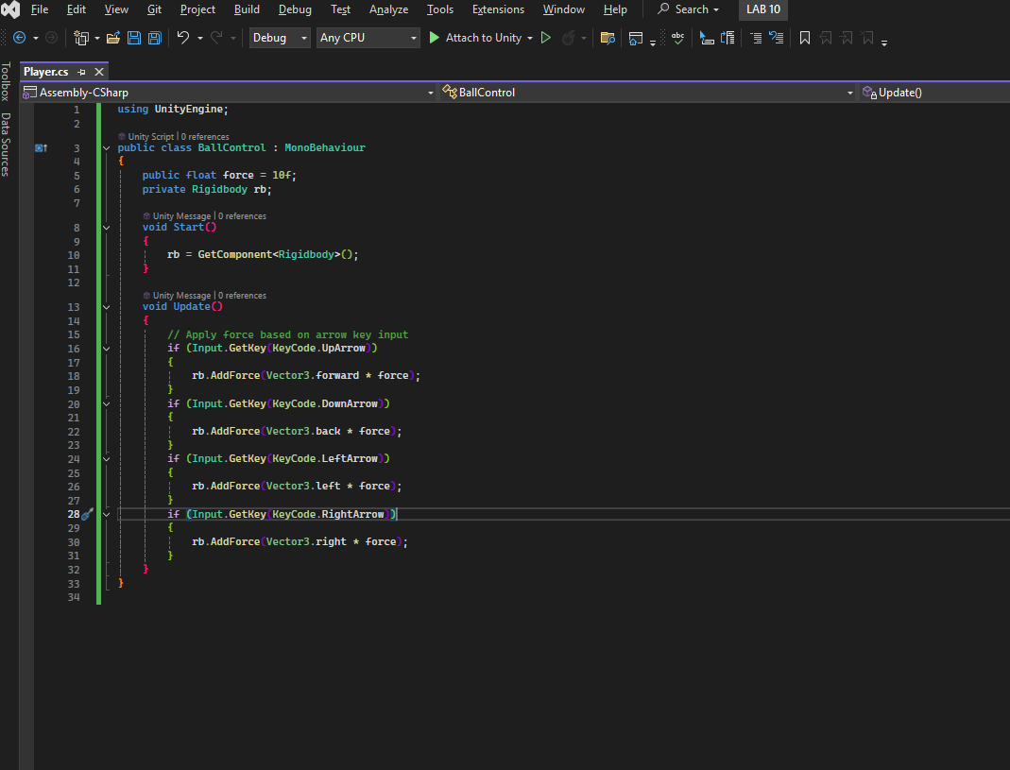

**7. Test and Tweak**